CS624 Full-Stack Development Mobile App
PE04 – Profile Cards

Part 2

Link:
https://github.com/rghlee/CS624-PE-Hannah-Lee.git
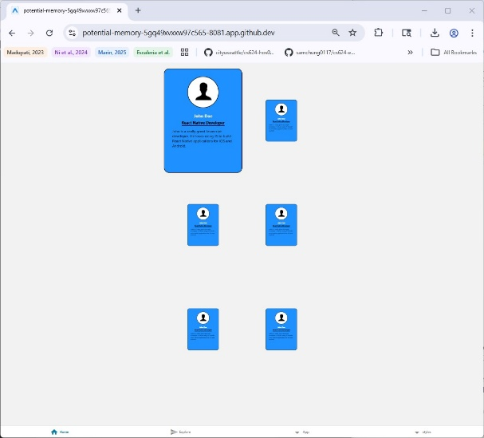
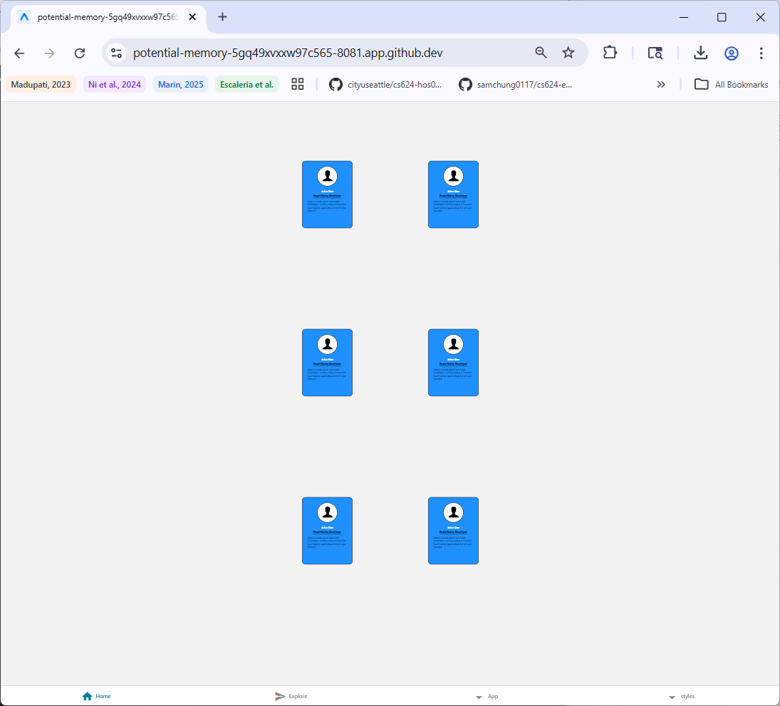

Summary:
The input for the program consists of profile data for each individual profile card. The data includes the user’s image, name, occupation and description. The input is managed as an array of objects in the state of the App component. Each profile object has a showThumbnail that determines whether the profile card is displayed in its full size or as a thumbnail. The program uses React Native’s FlatList to render the profile cards. Each profile card uses toggle function to change the showThumbnail state. When a profile card is clicked, the showThumbnail state is toggled, shrinking or expanding the card, using the transform: scale() to resize the card. The program handles 6 profile cards. The output of the program is a gallery of profile cards displayed in 2 columns. The cards are shown at their full size initially and when clicked, they shrink to a thumbnail size.

